My visit to Inflatable World

When I arrive at Inflatable World, we will enter and see many brightly coloured Jumping Inflatable Castles.
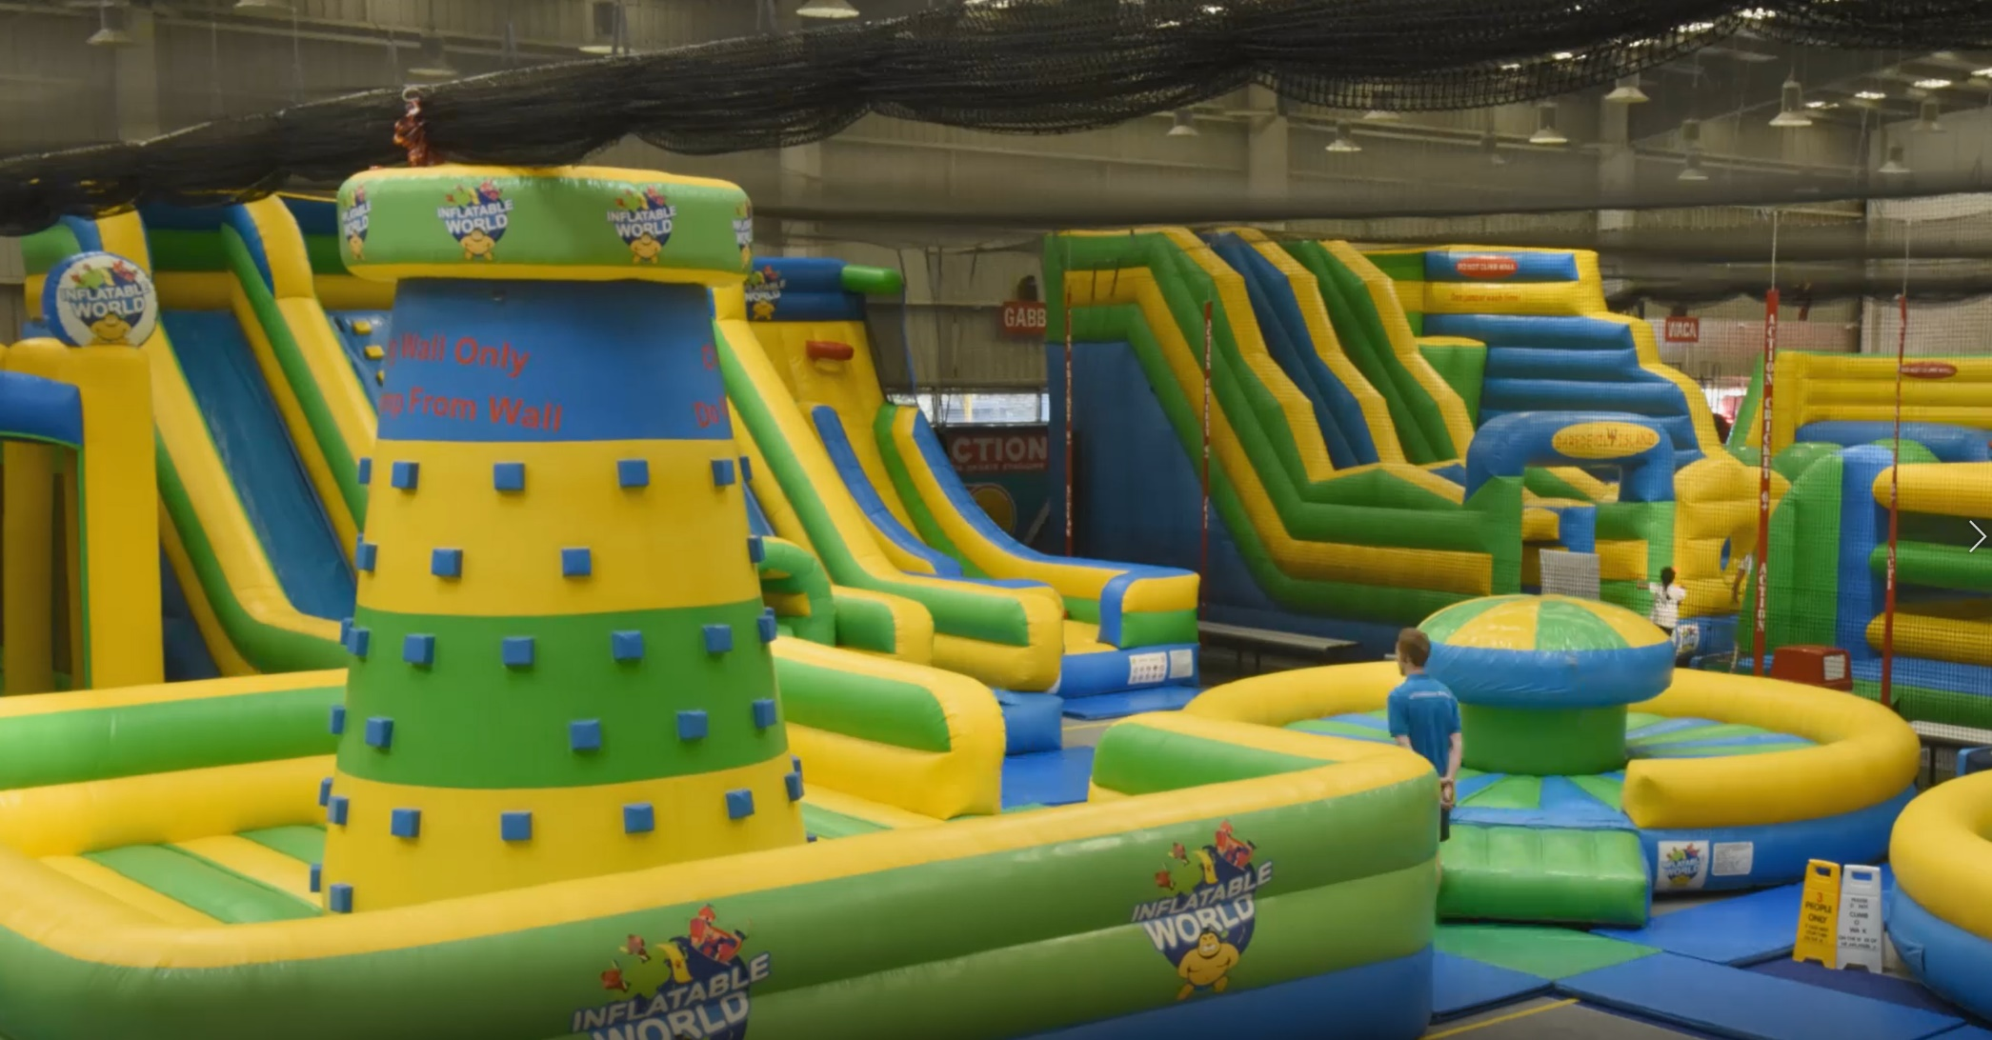
I will hear the humming sound of the motors that keep the Inflatable Castles full of air.

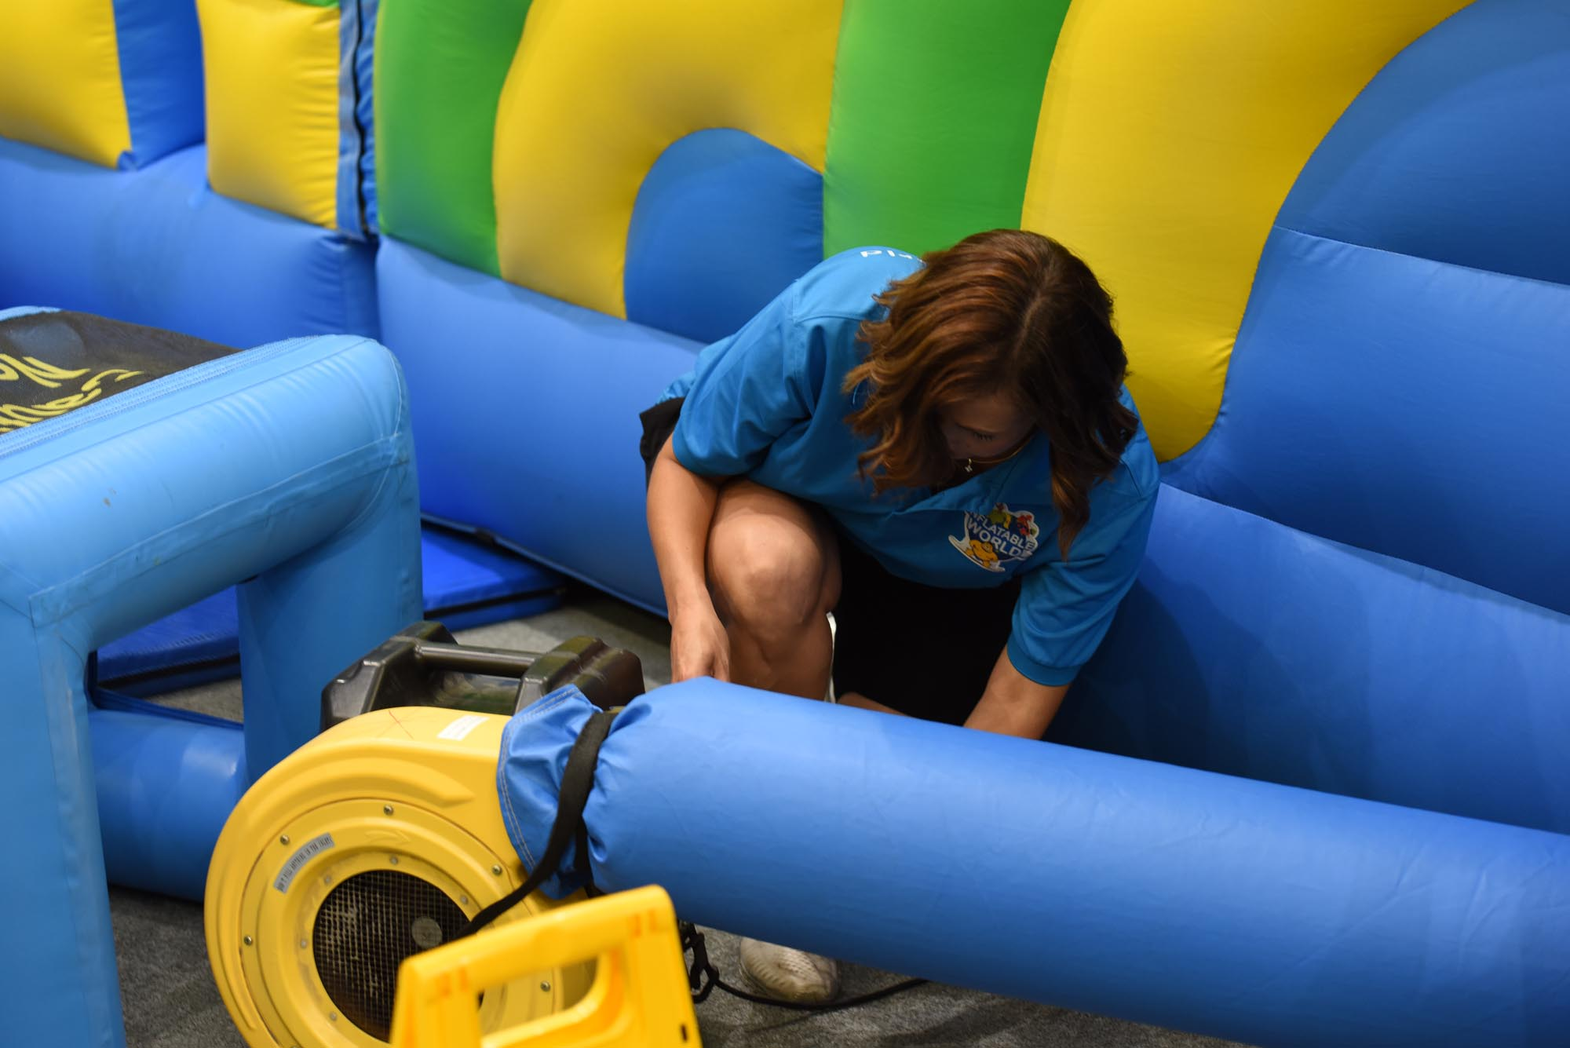

I will line up to get a special coloured wristband on my wrist to enter the Inflatable Playground area.
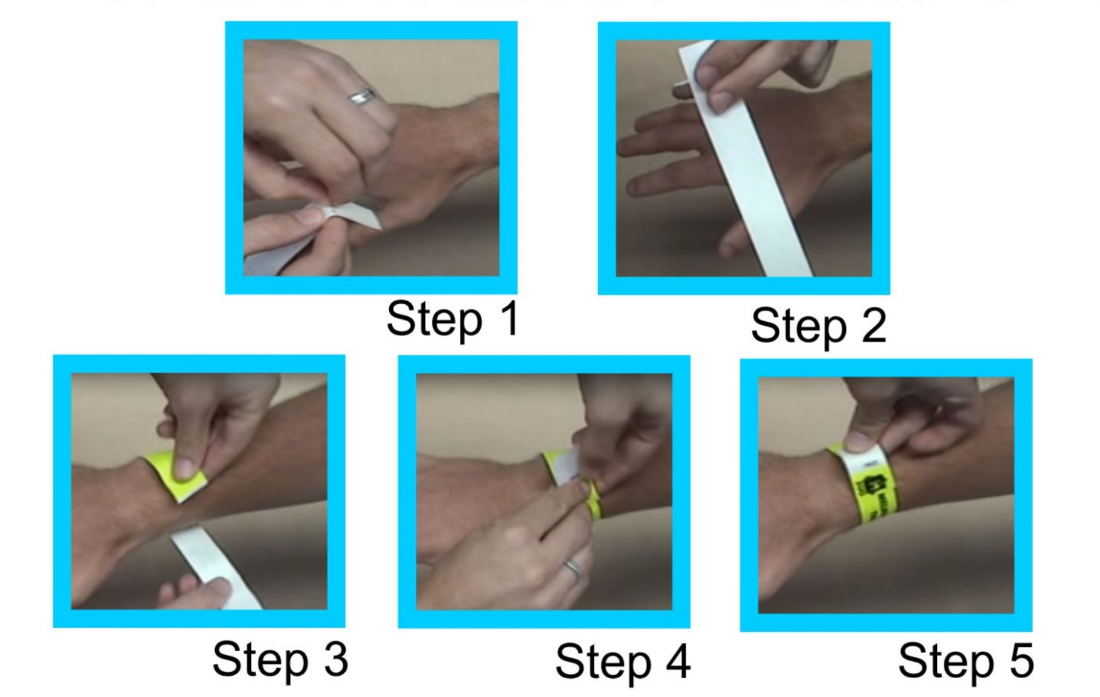
I need to take off my shoes and only wear my socks to play on the Inflatable castles.
I will join other children in playing on the Inflatable Castles where I can jump, climb and slide.

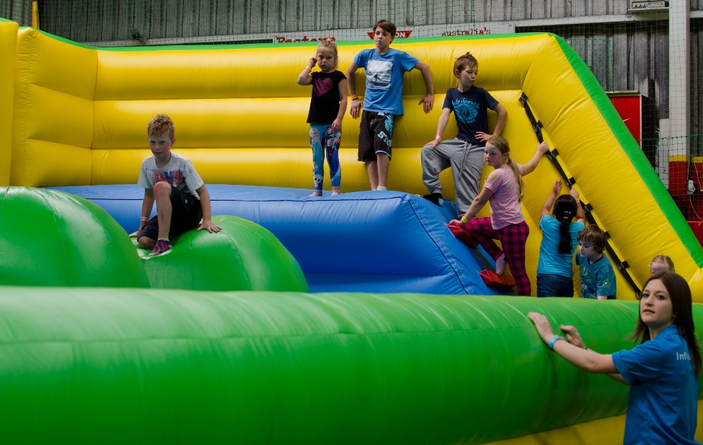

I will see people in blue shirts who are here to help me and the other children to play.

I need to follow the rules at Inflatable World. I will keep my socks on, not run or climb over the sides of the Inflatable Castles.
This will keep me and others safe and happy.

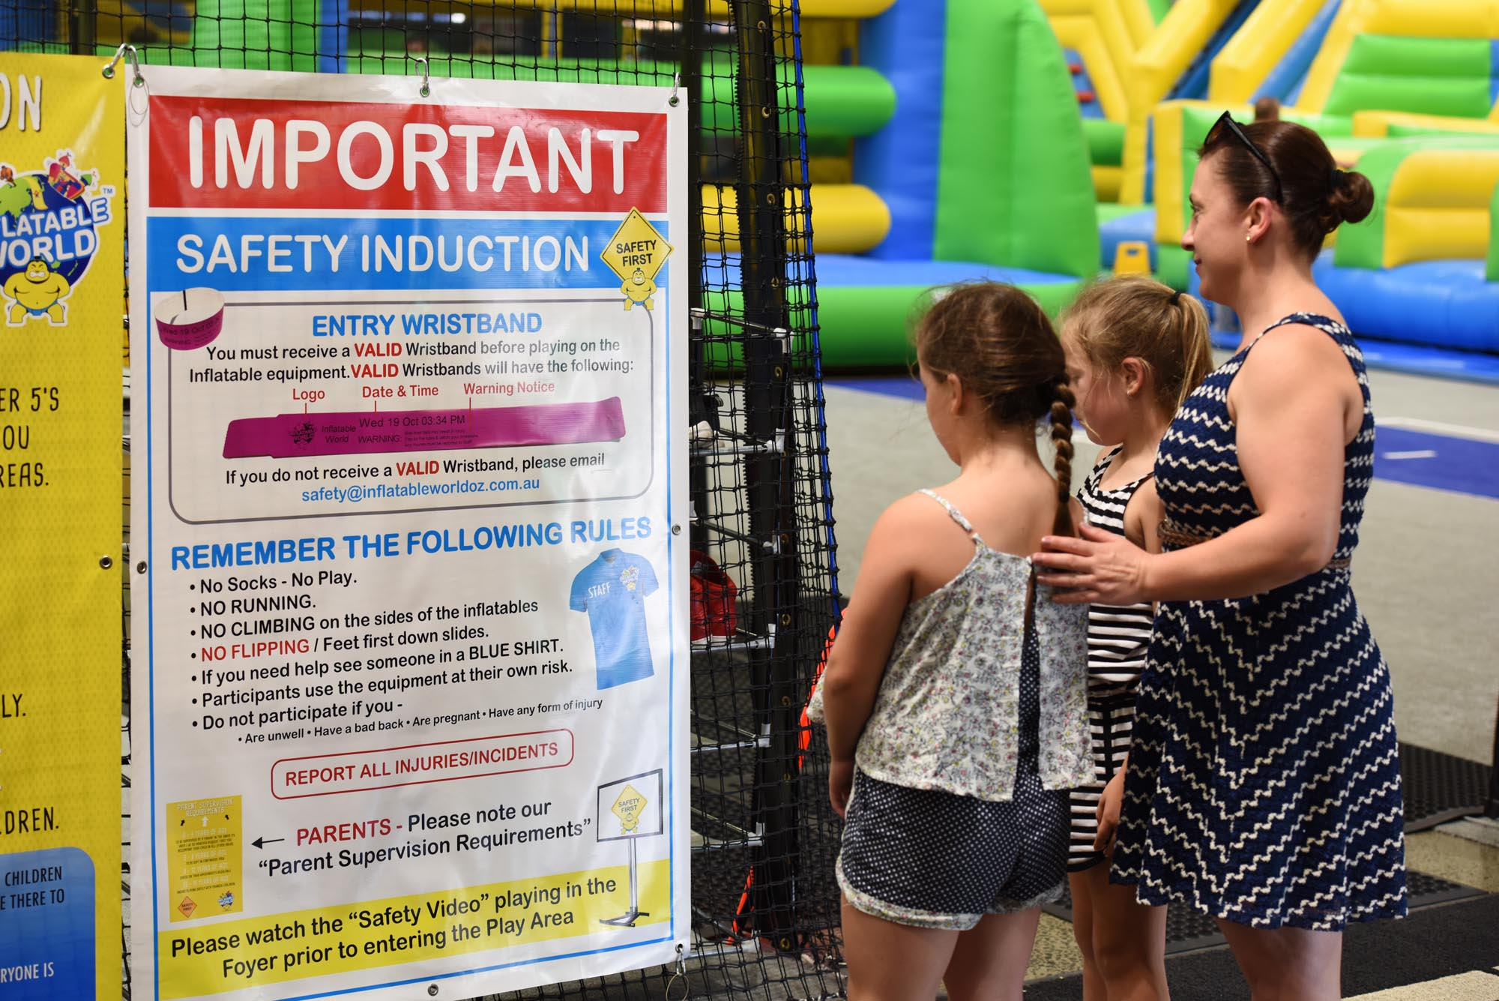 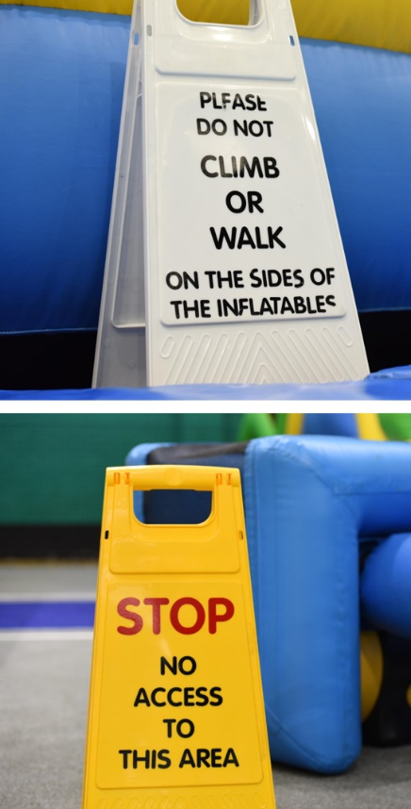
I can play for 2 hours on all the Inflatables before it is time to leave.

I had fun at Inflatable World.

